**KAMPALA PARENTS’ SCHOOL 2004**

**END OF TERM TWO 2023**

**MATHEMATICS**

**PRIMARY TWO**

DURATION: 2HRS 30 MIN

**NAME:** ....................................................................................................

**STREAM:** .........................................................................……………..…..

**SECTION A (40 MARKS)**

1. Add: 8

+5

1. Circle the bigger number: 70 and 100.

1. What fraction is shaded?

|  |  |  |  |  |  |  |
| --- | --- | --- | --- | --- | --- | --- |
| |  |  |  |  |  | | --- | --- | --- | --- | --- | |  |  |  |  |  | |  |

1. Show 253 in the abacus.

H T

0

1. Fill in hundred, tens and ones.

784 = ________ hundreds _______ tens _______ ones

1. Name this shape below.

__________________________

1. Add 3 +2 using a number line.

0 1 2 3 4 5 6 7 8

1. Multiply: 3 1

X 3

_______

1. Tell the time.

________________________

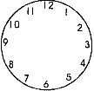

1. Name the set below.

__________________________________________________



1. If a cow has 2 ears. How many ears do 5 cows have?

1. Add: 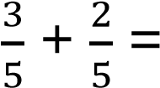
2. Use taller / shorter

Tree A is _________________ than tree B

**A**

Tree B is _________________ than tree A

**B**

1. Expand: 424 = ___________ + __________ + ___________

1. Write 46 in words: __________________________________________

1. Draw bundles of tens and ones for 24.

1. Write one hundred twenty four in figures ________________________

1. Find the missing numbers. – 3 =7

1. Divide: 15 ÷3 = ____________

1. Subtract: 7 4 3

-4 2 1

**SECTION B: 60 MARKS**

1. Study the sets below and answer the questions.

P= { 1, 2, 3, 4, 5, 6}

Q= { 1, 3, 5, 7, 9}

1. Represent the above information on the venn diagram

below.

(3

mrks

)



**P**



**Q**

1. How many members are in set Q? (1mrk)

1. List members of P U Q. (1mrk)

1. a) A chair has 4 legs. How many legs do 3 chairs have?

(2marks each)

1. A farmer had 30 cows, 10 of them died. How many cows remained?

1. Write the place value of underlined digit. (2mks @)
   1. 1 4 **5**  b) 1 **7** 0

_______________ _________________

1. **3** 8 7

1. Complete the puzzle below. (4mrks)

0

___ 4

5+

1 ___

5

1. Amos is 7 years old. Amon is 8 years old. (4 mks)

* 1. Who is younger. __________________________________________

* 1. Who is older. _____________________________________________

* 1. Find their total age.

1. Name the shapes below. (2 mks @)

|  |  |  |
| --- | --- | --- |
|  |  |  |
|  |  |  |

27. Work out: (Show your working) (2mks @)

a) 5 4 b) 2 8

× 2

(c) 4 6

9

28. Study the shopping list below and answer the questions that follow.

|  |  |
| --- | --- |
| Items | Cost |
| A ball | Shs 800 |
| A book | Shs 300 |
| A pen | Shs 200 |
| Cake | Shs 400 |

1. How many items are listed above? (1mk)

1. Find the cost of 3 pens? (2mks)

1. How much can you pay for a cake and a book?

(2mks)

29. Use a number line to answer the questions below.

(2mks@)

* 1. 4 + 5 = _______

0 1 2 3 4 5 6 7 8 9 10

* 1. 7 – 5= _____

0 1 2 3 4 5 6 7 8 9 10

1. Form small sets from the original set. (2mks@)

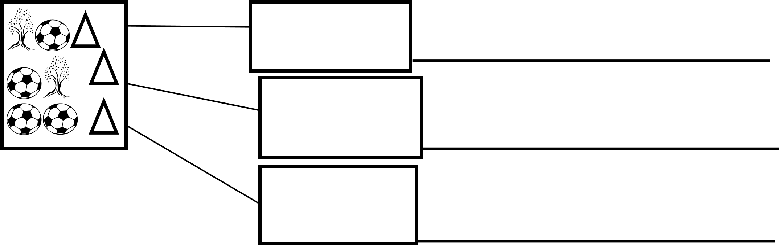

1. Arrange the numbers below in ascending order
   1. 20, 10, 5, 30 ______________________________ (2mks @)

* 1. 40, 45, 70, 25. ___________________________________

1. Study the table and answer the questions.

|  |  |
| --- | --- |
| Keneth |  |
| John |  |
| James |  |
| Joan |  |
| Amon |  |

* 1. Joan has ___________ balls. (1mrk)

* 1. How got two balls? (1mrk)

____________________________________________________

* 1. How many balls does John have? (1mrk)

______________________________________________________

* 1. Who has more balls? (1mrk)

______________________________________________________

* 1. How many balls do the children have altogether? (2 mrks)